
To: | Dr. Charlie Refvem, Mechanical Engineering, Cal Poly SLO, crevem@calpoly.edu
From: | Caiden Bonney, clbonney@calpoly.edu
Date: | September 22, 2025
RE: | Homework 0x00 - Reading CSV Files and Using matplotlib

Produced Plot
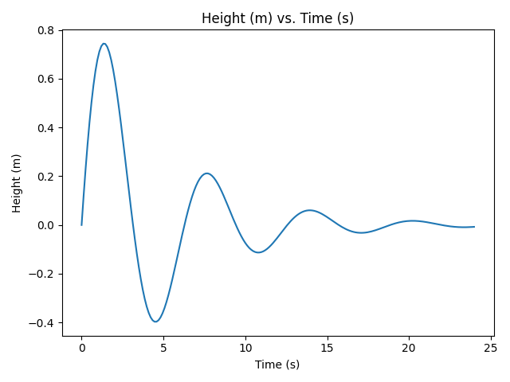

Log of Rejected Rows
Line 6 rejected due to empty line:
Line 7 rejected due to full-line comment: # 0.0 0.0 0.0, 0.0
Line 8 rejected due to empty line:
Line 12 rejected due to not enough entries: waffles!!!

Code
from matplotlib import pyplot as plt

# Function definition
def reject(reason, linenum, line):
print(f"Line {linenum} rejected due to {reason}: {line}")

# Variable initialization
file_name = "data.csv"
col_number = []
column1 = []
column2 = []
first = True

try:
# Open the file in read mode
with open(file_name, 'r') as f:
content = [l.strip() for l in f.read().splitlines()]

for linenum, line in enumerate(content, start=1):
# Skip empty lines
if not line:
reject("empty line", linenum, line)
else:
# Skip full-line comments
if line[0] == '#':
reject("full-line comment", linenum, line)
else:
# Remove in-line comments
line_no_comments = line.split('#')[0]

# Split lines at comma and strip whitespace
splitline = [s.strip() for s in line_no_comments.split(',')]

# Line only valid if containing at least two entries
if len(splitline) < 2:
reject("not enough entries", linenum, line)
else:
# First valid line is header
if first:
first = False
column1_header = splitline[0]
column2_header = splitline[1]
else:
# Convert first 2 entries to floats and add to respective columns
try:
entry1 = float(splitline[0])
entry2 = float(splitline[1])
# col_number.append(linenum) # line number also added for debugging if needed
column1.append(entry1)
column2.append(entry2)
except ValueError:
reject("invalid value type", linenum, line)
except FileNotFoundError:
print(f"Error: The file {file_name} could not be found.")
except Exception as e:
print(f"Error: {e}")

# Plot data if available
if not (column1 and column2):
print("No valid data to plot.")
else:
plt.plot(column1, column2, label=column2_header)
plt.title(f"{column2_header} vs. {column1_header}")
plt.xlabel(column1_header)
plt.ylabel(column2_header)
plt.tight_layout()
# plt.legend()
# plt.grid()

# Save plot as image
# plt.savefig("data.png") # Comment or uncomment to save plot as png

# Display the plot
plt.show()

